London Bike Box Hire

How to Pack - Bike Box Alan
- It is recommended that you start with a clean bike, especially the group-set as this makes for easier packing and re-assemble.
- If you have disc brakes the wheels can be packed in the same way as wheels without discs (see photo below). If packed with the discs facing into the foam make sure there is nothing packed into the base of the box that will push into the discs and potentially bend them. You may want to consider removing the discs, although I am yet to be advised by any of my clients that they have taken this approach. Either way it is your decision.
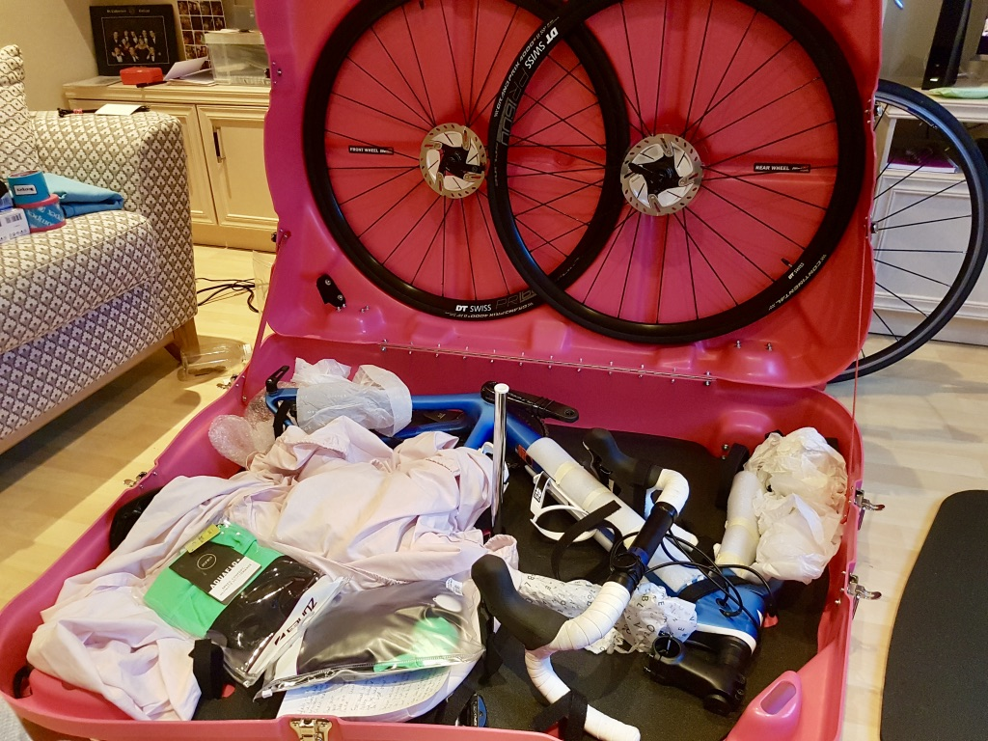
- If you have thru-axels you will need a set of quick release skewers to secure the wheels into the lid of the box.
- Move chain to small sprocket on the rear cassette and the large sprocket on the front.
- Remove pedals. Remember the right pedal (that’s the pedal that you push/pull with your right foot), has a normal thread. The left pedal has a reverse thread.
- Mark seat post position.
- Loosen and remove seat post and saddle.
- Tighten.
- Remove headset top bolt and collar (keep safe).
- Loosen handlebars, but do not remove.
- Remove air from front tyre.
- Remove front wheel.
- Place front wheel in the lid of the box.
- Make sure the end of the skewer does not stick out from the cap.
- Remove air from rear tyre.
- Remove rear wheel.
- Pace rear wheel in lid of box (cassette facing into the recess).
- Make sure the end of the skewer does not stick out from the cap (see photo below).
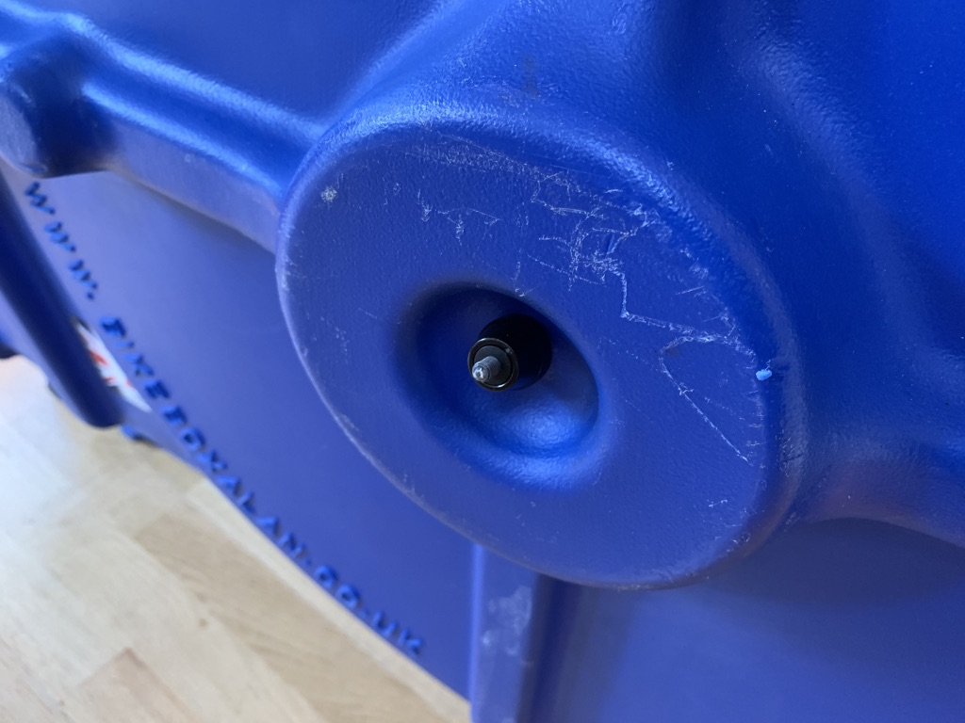
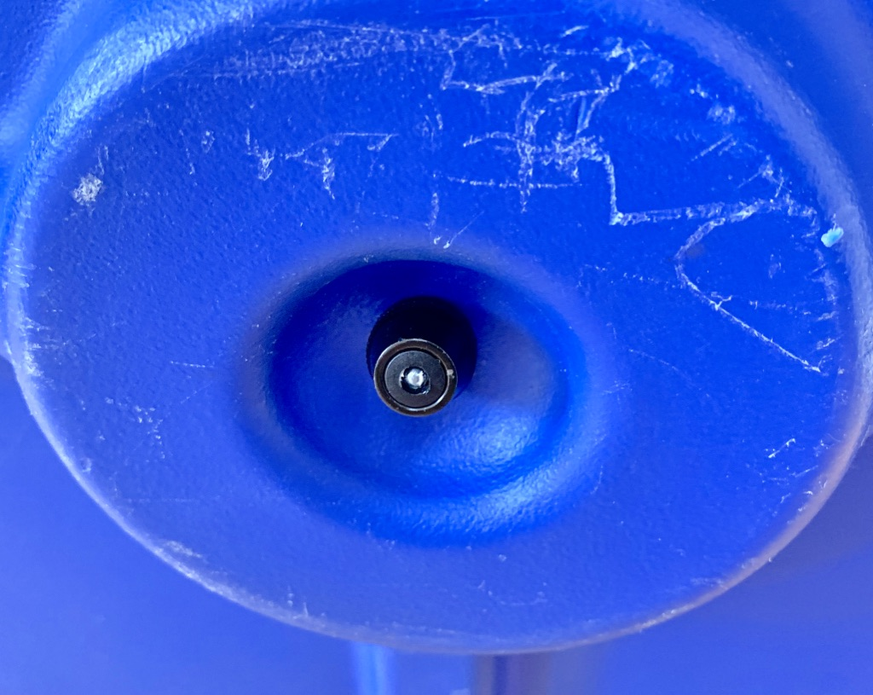
- Remove handle bars.
- Replace headset top bolt and collar.
- Place frame into box, with rear derailleurs against the foam. It is recommended to wrap the rear derailleurs and chain ring with bubble wrap, an old towel or t-shirt etc. This will also protect the crankset/chainset and box from rubbing together. For an extra-large frame it is recommended to seat the frame as in this diagram:
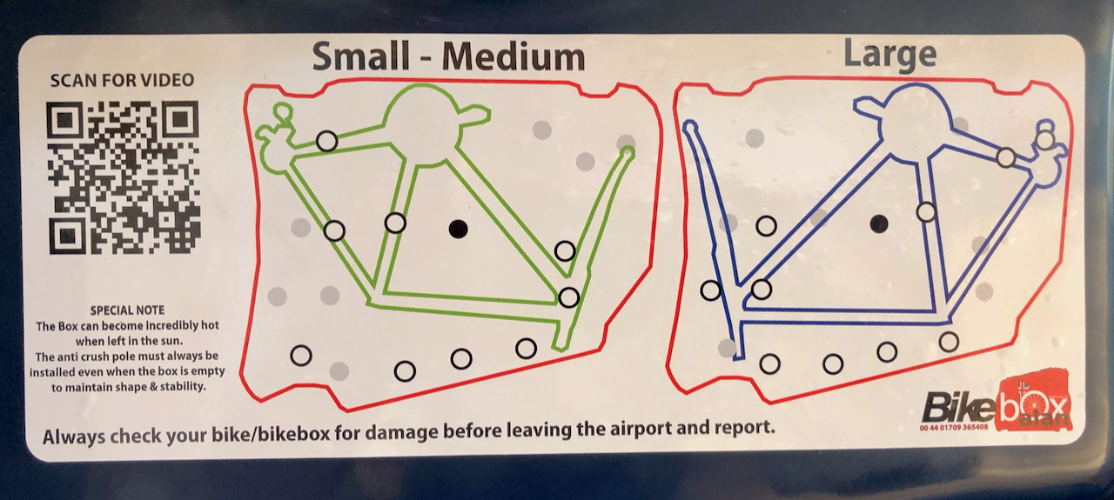
- Secure frame and handlebars.
- Add accessories according to space and weight restrictions.
- Use plenty of bubble wrap and additional padding where required.
- Place top foam and anti-crush bar (make sure there’s a gap in the wheel spokes).
- Close and secure clasps. You may need to wiggle the lid and base to make sure the clasps are fully secure so that the five male clasps on the lid are properly inserted into the female clasps on the base. Failure to do this will result in damage to the box and clasps.
- Use zip ties for added security.

